Operational Manual

Battery Discharge Tester
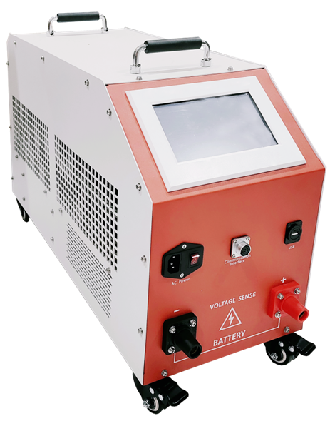

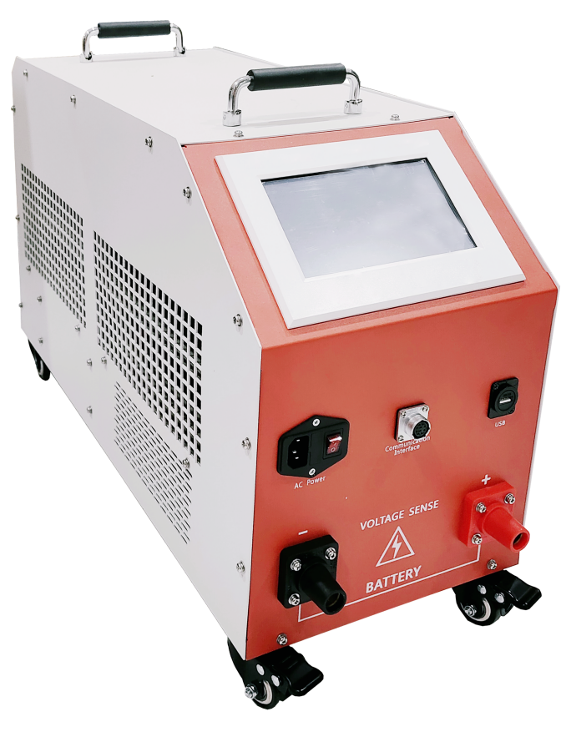

WUHAN GOLDHOME HIPOT ELECTRICAL CO.,TLD

Tel.：+86-13720265142 Fax：+86-27-84625205
Email：goldhome03@cablehipot.com Web.: www.cablehipot.com
Add.: No.A25-1, Huading Mould Industrial Park, Hannan, Wuhan, Hubei, China

CONTENTS

Product Introduction 3
1.1 Product Summary 3
1.2 Product Features 3
Technical Specifications 7
2.1 Product Dimensions 7
2.2 Technical Specifications 9
Testing Procedure 11
3.1 Testing Procedure Introduction 11
3.2 Interface and Wiring Instructions 13
Testing Methods 15
4.1 Precautions before using the product 15
4.2 Wiring 15
4.3 Product Operation 18
After-sale Service 32
Precautions and Maintenance 32
Appendix 1: Operating instructions for the battery capacity tester software 34
Software function 34
1. USB data reading, display and storage； 34
2. Test report generation； 34
Installation and operation 34
U disk data read, display and storage 34
Report Export 36
Appendix 2: Lead-acid battery discharge coefficient corresponding table 38
Appendix 3: Common Instruments and Wiring Troubleshooting 39
Declaration 41

Product Introduction
  - Product Summary
HM-300V/150A Battery Discharge Tester actually discharges the battery pack through the built-in electronic load, which meet the discharge test of battery packs with multiple voltage levels (10-300V). The tester can monitor the battery voltage, discharge current, discharge time, discharge capacity and other parameters in real time during the discharge process. It is applicable for the activation and discharge of various batteries, the discharge during the initial charge of the battery, and the maintenance and discharge of the battery. It can also check the battery power storage performance and load capacity, etc.. The tester has the advantages of simple operation and safe discharge.
This instrument adopts the current advanced testing technology principles, and has made a series of breakthroughs in the research and application of new technologies, new devices, new materials, and new processes. It is designed in accordance with the requirements of relevant national testing and maintenance regulations to test the performance of batteries. The instrument has large discharge power, small size, light weight, and complete functions of the upper computer data management software, which greatly reduces the workload of daily battery testing and maintenance. The tester provides comprehensive scientific testing methods for battery and UPS power supply maintenance.

1.2 Product Features
- The product uses customized nickel-chromium alloy resistors as the load source. Low resistance value; can achieve a larger current discharge, customized appearance makes the power density higher. High precision; accuracy can be controlled within ±0.001Ω, as a load source to make the discharge process more stable. Low temperature coefficient; little influence by temperature coefficient, strong environmental adaptability. Resistant to current impact; strong current resistance, can quickly respond to large current impacts, and the discharge process is more reliable.
- Smart chip control. Intelligent control of the discharge process, automatic adjustment following the drop of battery voltage to ensure constant current discharge. The voltage of a single battery is collected in real time and displayed in a curve manner, which is convenient for evaluation and analysis. At the same time, it intelligently analyzes the battery voltage status and makes an evaluation. Intelligently calculate the conversion between the discharge capacity and the discharge hour rate to achieve the best evaluation effect of the battery capacity status. A variety of threshold thresholds can be set, intelligent judgment.
- Discharge test function. After the battery pack is separated from the system, the smart battery tester is used for constant current or constant power discharge, or the smart battery tester is connected in parallel with the user equipment for constant current discharge. After setting the discharge voltage, discharge current, discharge time, discharge capacity and other parameters, the tester will automatically perform the discharge and display the discharge current, battery discharged capacity, whole group voltage, single battery voltage, and discharge time in real time. The discharge parameters can be modified during the discharge test. The discharge test can be stopped when the battery pack reaches the set value of termination discharge voltage, termination discharge capacity setting, termination discharge time setting, any single battery voltage is lower than the termination single voltage setting value or manual termination operation.
- 7-inch large LCD touch screen: It adopts a 7-inch large-size bright touch screen with a resolution of 1024x600, which can be clicked directly on the screen. It is simple and clear, with strong anti-interference ability.
- LORA wireless monomer monitoring module (optional): compatible with 2V/4V/6V/12V single cell monitoring. Each wireless monitoring module can monitor 6 cells at the same time. Compared with the method of monitoring the voltage of one cell per module, the number of modules that need to be configured is only 1/6 (only 4 monitoring modules for 48V), so that the wiring for modules is easier than the old method.
- Module frequency settings: the host supports the acceptance and modification of multi-frequency for wireless single monitoring module, in avoid to interfering while using multiple testers or close range using multiple testers in the same room. Support up to 1-10 frequency receiving.
- Automatic discharge current calculation function: built-in discharge coefficients for each hour rate, which can automatically calculate the discharge current that needs to be set according to the nominal capacity of the battery under test and the required discharge rate.
- During the process of battery charging and discharging, the voltage of each cell is detected and displayed in real time: the track of each cell voltage histogram is displayed on the host screen, and the data table is supported. It can also automatically display the cell with the highest and lowest voltage in real time to help you quickly analyze the trend of individual changes.
- Discharge curve view: The voltage and current curves of the battery pack during the discharge process can be reviewed.
- Built-in multiple discharge templates: The instrument has built-in up to 6 groups (expandable) test templates for selection, making testing more convenient. You can also modify and choose the test template by yourself.
- Quick test function: The instrument can automatically identify the battery voltage after it is connected to the battery pack and the user can start the test with one key without setting any parameters.
- Data transfer: The host is configured with U disk for data transfer, and the data analysis software can analyze the data and support report generation.
- Multiple choices of discharge modes: the host comes along with three discharge modes: constant current discharge, constant power discharge, constant voltage discharge, providing customers with a variety of test mode choices for better performance testing.
- Master-slave mode parallel testing: supports multiple hosts to be used in parallel. (Optional, and the communication cable needs to be configured.)
- Power failure test function: during the discharge test process, the utility power failure will result in the host loses power supply. when the host utility power supply is restored, the host will automatically resume from the stopped point to continue, which can ensure that the test data is continuous and uninterrupted and guarantee the integrity of the test process automatically.
- Internal resistance test: the host supports testing the internal resistance of each single battery and supports coefficient modification, and the measured internal resistance value is available for customers' reference (wireless single monitoring module is required).
- Online monitoring: the host supports online monitoring function, when the host opens the function, the main interface of the host to increase the "online monitoring" main function option, enter the function interface can be on the battery pack voltage, current online monitoring and record the current, capacity, time data and can generate a report, so as to facilitate the customer to determine the health of the battery. (Optional, single module and current clamp need to be configurated.)
- Reserve RS485 host port: battery single-cell voltage acquisition. (Extended function, not open by default)
- Reserve RS485 slave port: accept remote control. (Extended function, not open by default)
- Reserved CAN communication port: receive CAN signal input reading (extended function, not open by default)

Technical Specifications

2.1 Product Dimensions
Model | HM-300V/150A Battery Discharge Tester
Appearance
Weight | Main unit 23(kg)
Dimensions  (mm) | 645*263*425mm(WxDxH)

2.2 Technical Specifications
Power Input-AC | Single-phase AC 220V, the frequency range is 60Hz.
Operation mode | Touch screen
Display | 7 inch TFT LCD screen, resistive touch screen, resolution 1024x600
Communication | RS485x1 (not open by default)
Internal data storage | 128MBit
Voltage measurement accuracy | ±0.5%FS+0.1V
Current measurement accuracy | ±1%FS+0.1A
Group voltage display accuracy | 0.1V
Group current display accuracy | 0.1A
Discharge current control accuracy | ±1%FS
Discharge Voltage Range | 10-300V
Discharge Current Range | Voltage Range One: 10–20V Current: 0–40A continuously adjustable  Voltage Range Two: 20–40V Current: 0–80A continuously adjustable  Voltage Range Three: 41–60V Current: 0–150A continuously adjustable  Voltage Range Four: 61–245V Current: 0–100A continuously adjustable  Voltage Range 5: 246-300V Current: 0-60A continuously adjustable
Protection | Over temperature, over current, current out of control trigger shutdown protection
Emergency stop | High voltage DC switch 250A
Reverse connection protection | Support
Abnormal protection | Power line power failure protection, main cable power failure protection
Over temperature protection | Resistance box over temperature 85℃; radiator over temperature 100℃
Alarm reminder | LCD display + buzzer
Safety test
Withstand-voltage test | AC input-chassis: 2200Vdc 1min AC input-chassis
Withstand-voltage test | DC input-output: 2200Vdc 1min DC input-chassis
Working temperature
Cooling | Forced air cooling
Temperature | Operating temperature range: -5~50℃; storage temperature: -40~70℃
Humidity | Relative Humidity 0~90%（40±2℃）
Altitude | Rated 2000 meters above sea level

Testing Procedure

3.1 Testing Procedure Introduction
Step 1: Connect the single cell modules. (Please note that single cell acquisition modules are optional accessories.)
Step 2: Turn the switch on the tester to the “OFF” position. (To prevent reverse connection of the discharge cable and damage to the instrument).
Step 3: Connect one end of the discharge wire to the tester and the other end to the battery pack. (Note that red is positive and black is negative)
Step 4: Connect the entire set of voltage test leads to the 2-terminal of the battery pack.
Step 5: Connect the tester to the AC220V power supply and close the AC air switch.
Step 6: Plug in the power supply and turn on the tester.
Step 7: Enter the discharge and charge parameter settings.
Step 8: Turn the discharge switch to the “ON” position.
Step 9: Click "OK" to start the test.
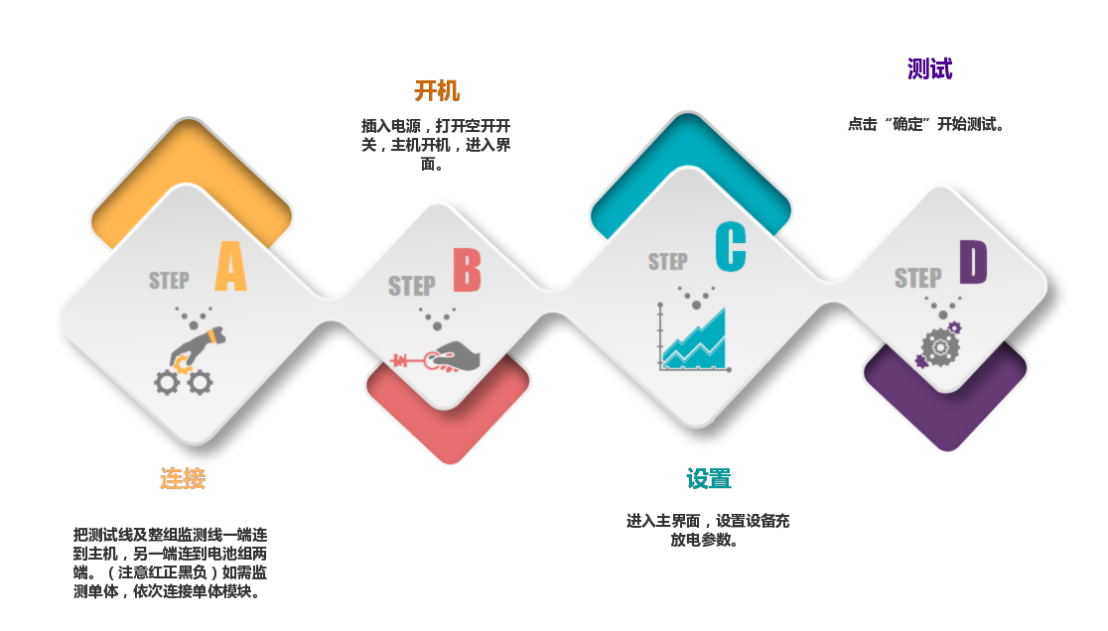
Settings
Connection
Test
Power On
Quick-start Flow Chart

3.2 Interface and Wiring Instructions
3.2.1 Instrument Interface
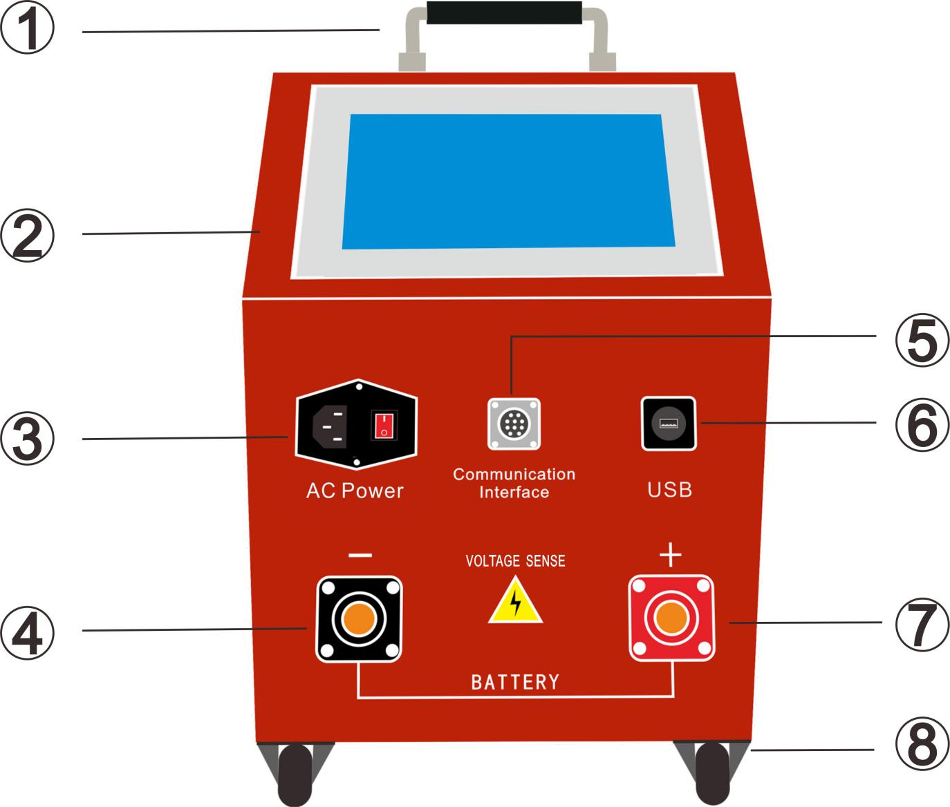

Series No. | Function | Series No. | Function
 | Handle |  | External communication expansion connector
 | - inch touch LCD screen |  | USB data transfer connector
 | Single-phase 220 AC Input |  | Battery positive inlet
 | Battery negative inlet |  | Wheel

Testing Methods

4.1 Precautions before using the product
- The control system of the equipment uses AC power supply, and an uninterrupted AC power supply needs to be maintained during work.
- The good ventilation should be ensured during work. The air inlet and outlet should not be blocked within 1 meter.
- The equipment should be used indoors. Keep the equipment dry, free of corrosion, condensation, and well ventilated.

4.2 Wiring
4.2.1 Wiring Diagram:

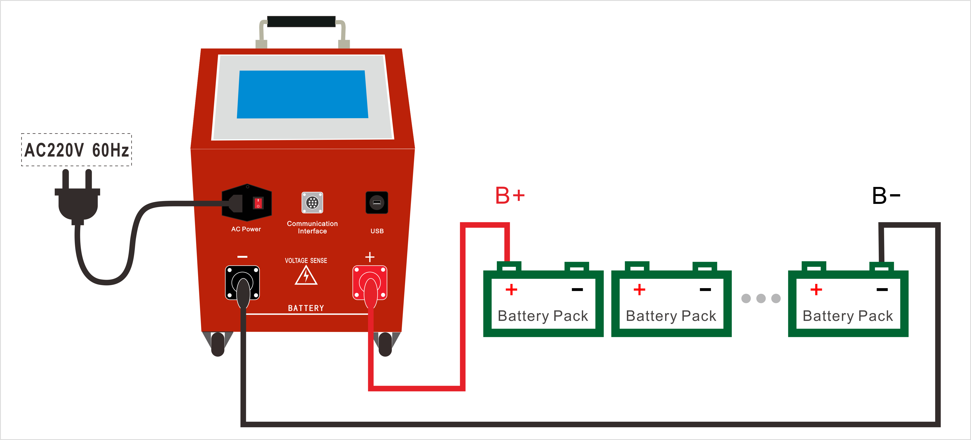

4.2.2 Connection：

Insert the quick connector of the discharge cable into the quick socket of the tester (red positive and black negative), and then connect the other end of the discharge wire to both ends of the battery pack (red positive and black negative).

4.2.3 Module connection steps：
Step 1: Determine the number of single modules that the entire battery pack needs to use.
- The number of modules = the number of cells in the entire battery pack ÷ the number of cells that can be monitored by a single module. If it is not divisible, the number of modules needs to be added by 1.
- For example: if the number of battery cells in the battery pack is 6 cells, the configured single module can monitor 6 cells, 110÷6=18.33, which is not divisible, so the number of modules to be used=19.
Step 2: Wire between the single module and the battery. (Single module starts from module 1)
- The single module is connected to the single battery, please collect and connect according to the corresponding battery number! First collect the connection between the cable and the battery, and then supply power to the module.
- The wiring sequence of the voltage collection line and the battery is: take the positive pole of the battery pack as the starting of the wiring, and start from the negative pole of the battery pack according to "red, green 01, green 02...green 05, green 06, black". When using multiple single modules, according to the single module number, from front to back, all the collection lines of the single module are connected. : differential pressure ±8V or more).

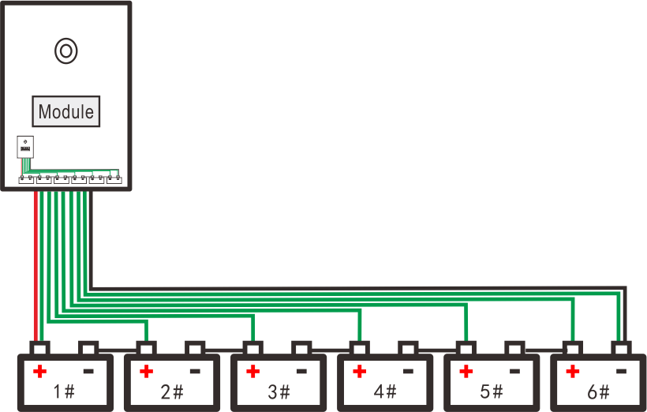
Wiring diagram of 6 cells and above

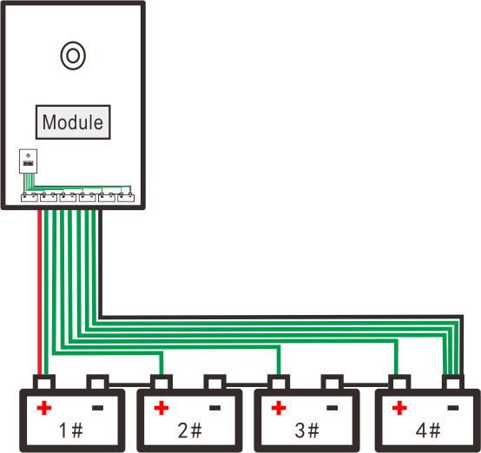
Wiring diagram of 6 cells and below

Note:
Since this module takes power from the cells, the minimum monitorable battery data is 4 cells, and the wires to be taken are No. 0 and No. 4 respectively. Do not connect wrongly or reversely during the wiring process, otherwise the module may be burned out.

- The power supply of the single module. The power supply voltage difference of the single module is more than 8V, which is powered by the red and black power lines separately. Do not reverse.
Power supply method, if the cell voltage of the battery pack currently measured is 2V, the power is taken from 4 batteries; the single cell voltage is 6V, and the power is taken from 2 batteries; the single cell voltage is 12V, and the power is taken from 1 battery . Note that power is required for each single module.
- After the single module is powered on, the single voltage indicator on the corresponding module flashes normally.

4.3 Product Operation
A. Test Main Interface-Power on the machine and enter the discharge test main interface directly.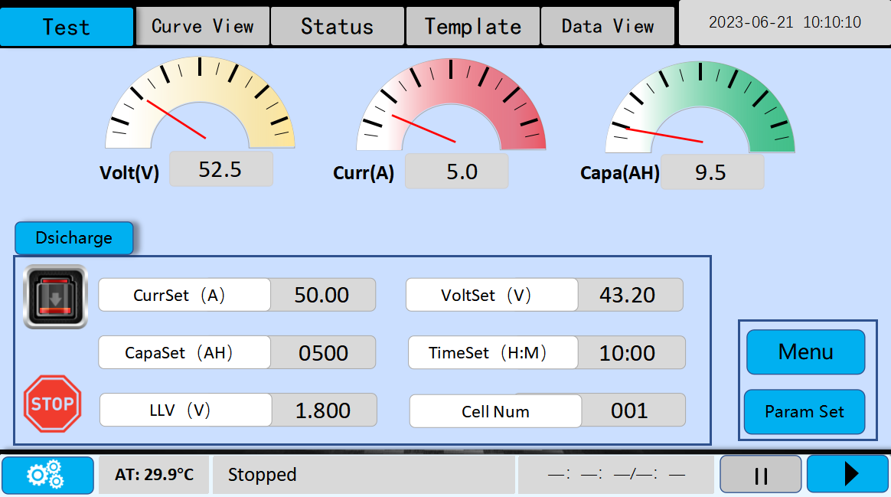

B. Online Monitoring Main Menu
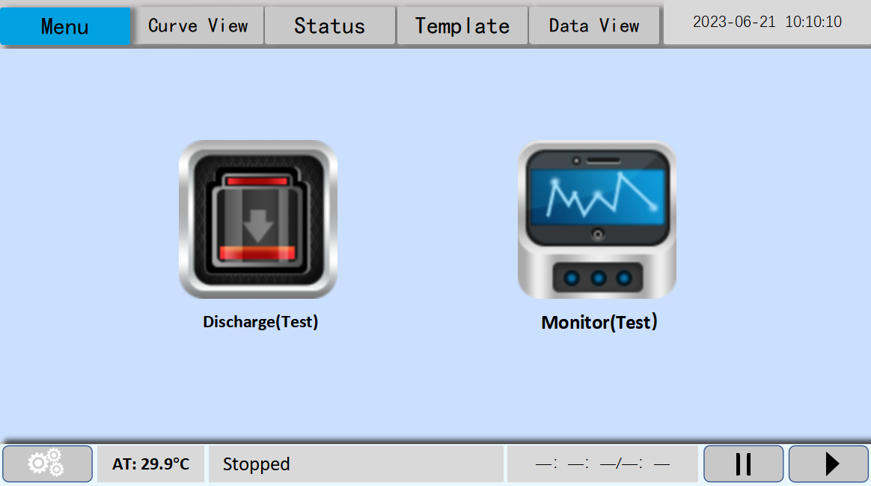
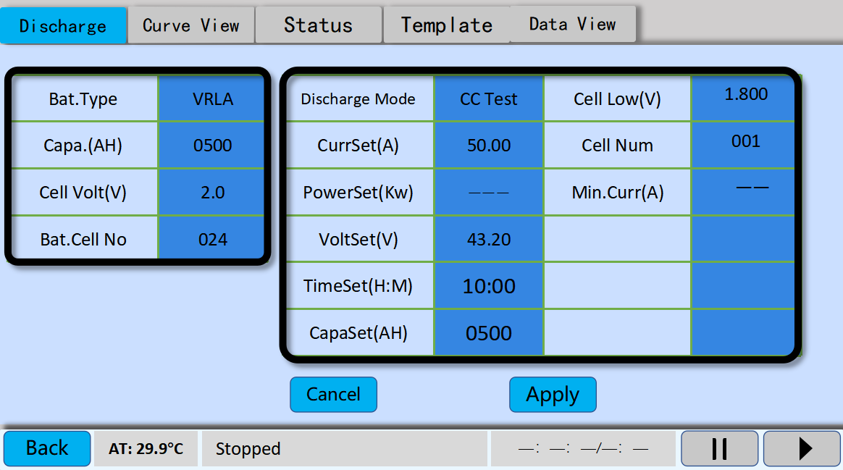
- Turn on the power switch to enter the main interface of discharge test and click "Param Set" to enter the discharge parameter setting interface.

- "Bat. type": It provides 5 types to choose from: lead-acid, lithium iron, lithium ternary, lithium titanate and lithium manganese, according to the actual battery type.

- "Capa. (AH)" : Click on the reading to pop up the keypad to enter the actual nominal capacity of the battery.

- "Cell Volt (V)": Click on the reading to pop up the keypad to enter the actual nominal voltage of the battery.

- "Bat Cell No.": Click on the reading t tohpok up theeyboard to enter the actual number of battery cells. Note: This item is related to the display of the voltage meter and the voltage curve, so please make sure to fill in the correct number of cells connected.

- "Discharge mode" : There are 3 discharge modes: “constant current (CC Test)", "constant voltage (CV Test)", and "constant power (CP Test)" to choose from, and click to switch among the 3 modes.
      - Constant current mode
In constant current mode, the tester discharges at the set current value and stabilized at the set discharge current value, and the tester automatically adjusts the discharge current according to the change of group end voltage. In constant current mode, "pre-discharge power" and "current threshold" parameters are not effective.
2. Constant voltage mode
Set the pre-discharge voltage value as the constant voltage value, after the set value, the tester starts to constant output at the set value of constant voltage, and reaches the set current threshold to complete the discharge. The parameters of "pre-discharge voltage" and "current threshold" are effective in constant voltage mode.
3. Constant power mode
Regulate the discharge current to achieve constant power discharge based on the pre-discharge power and the actual connected battery pack voltage. For example, if the pre-discharge power is set to 5KW, and the battery pack access voltage is 100V, then the host outputs a discharge current of 5000W/100V=50A, and when the battery pack voltage starts to drop during the discharge process, the tester will adjust the discharge current to ensure that the set power value is outputting constant power discharge.

- “CurrSet (A)”: Click the reading to pop up the keyboard and input the current to be discharged by the battery pack. Generally, take the 0.1C,10H as discharge rate for calculation, for example, battery pack nominal capacity is 100AH, then the pre-discharge current is input 100AH/10H = 10A. Refer to the appendix of this user’s manual for detailed description on Battery pack discharge multiplier and current.
- "PowerSet (KW)": Click the reading to pop up the keyboard and enter the total power to be discharged by the battery pack, this item is effective in "Constant Power Mode", please refer to the description of "Constant Power Mode" for details.
- "VoltSet (V)": Click the reading to pop up the keyboard and enter the lower limit voltage value of the battery pack. The tester stops discharging when reaches up to the set value.
- "TimeSet (H:M)": Click the reading to pop up the keyboard and enter the total time of battery pack discharge, you need to enter according to the format (hours: minutes: seconds) such as (10:00:00) Please strictly follow correct input format. Otherwise, the input is invalid and cannot be saved.
- "CapaSet (AH)": Click the reading to pop up the keyboard and enter the capacity of the battery pack that needs to be discharged.
- "Cell Low (V)": Click the reading to pop up the keyboard and enter the lower limit of single battery discharge after the connection of modules. The lower limit of a 2V cell is 1.8V and 10.8V for a 12V cell.
- "Cell Num ": Click the reading to pop up the keyboard and enter the number of single cells getting to the lower limit for shutdown protection after the connection of modules. The default number is 1, if set the number to 2, then in the process of discharging, the tester will be shut down to protect when there are 2 cells getting to the lower limit.
- “Min. Curr (A)” : Click the reading to pop up the keyboard and enter the current threshold for the battery pack to reach the lower limit in constant voltage mode. Please note that this function item is only effective in constant voltage mode.
- “Internal Resistance”: Disabled by default. 。For example: set 10A discharge current, the tester first sends 20% of the set current, stabilizes 2A discharge for 50S, then sends 80% of the discharge current, stabilizes 8A discharge for 50S, and then sends 100% of the current 10A constant current and maintains it, and then the tester displays the value of each battery's internal resistance in the interface of the battery status after the completion.
- After the parameter setting is completed, click"Apply "to save the modified parameters, and the interface jumps to the main discharge interface.
- "Volt”: displays the real-time group terminal voltage value of the plugged-in battery bank.
- "Cur": displays the real-time current value discharged by the battery pack after starting the discharge.
- "Capa": displays the actual capacity after discharging.
Discharge parameter column, displaying the set discharge parameters, which can not be modified, here to confirm whether there is any error in the discharge parameter setting, if there is no error, then the next step, if there is any error, then click on the "parameter setting" icon to enter the discharge parameter setting interface to reset the parameters.

- “” : indicates discharge mode.

- “”:The icon corresponds to the threshold column displaying the set shutdown protection parameters

- “”:click this button to start the discharge test, the status bar displays the discharge status accordingly, and the time starts to count.

- “”: click this button to stop the discharge test, the status bar accordingly shows the discharge status "stop test" time to stop timing.

- Working mode selection: Online monitoring
- Monitor: While the discharge tester is performing the test or the battery pack has a load current, the tester can monitor the voltage and current of the battery pack, display the voltage and current curves and save up the data, generate reports to analyze the health status of the battery. The function of “Monitor” needs to be enabled when necessary and please consult our technical staff to start up this function.
- Click "Monitor" on the main menu to enter the main interface of online monitoring parameter setting.

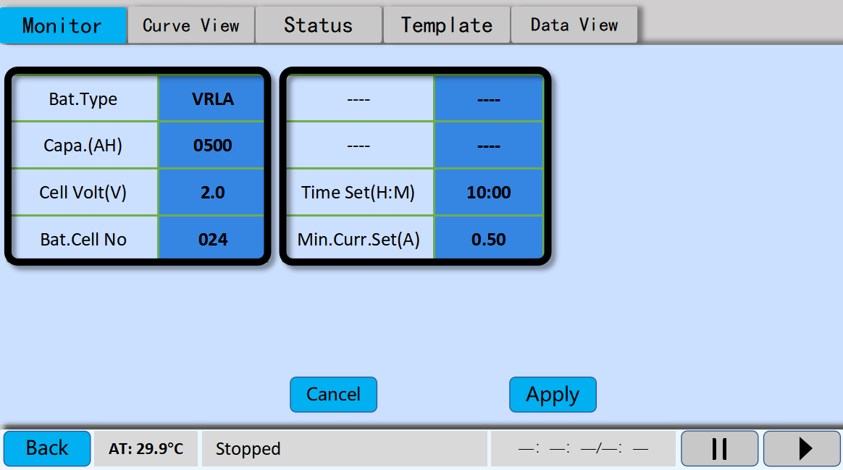
- "Bat. Type": It provide 5 types to choose from, lead-acid, lithium iron, lithium ternary, lithium titanate and lithium manganese, according to the actual battery type.

- "Capa. (AH)": Click on the reading to bring up the keypad to enter the actual nominal capacity of the battery.

- "Cell Volt (V)": Click on the reading to bring up the keypad to enter the actual nominal voltage of the battery.

- "Bat Cell No": Click on the pop-up keyboard to enter the actual number of battery cells. Note: This item is related to the display of the voltage meter and the voltage curve, so please make sure to fill in the correct number of cells connected.

- "TimeSet (H:M)": Type in the total amount of time to be monitored, and the tester stops monitoring until it reaches the set time.

- "Min. Curr. Set (A)": The tester stops monitoring until it reaches the predefined lower limit current.

- After the completion of parameter setting, click "Apply" to save the modified parameters, and the tester will jump to the main interface of "Monitor".
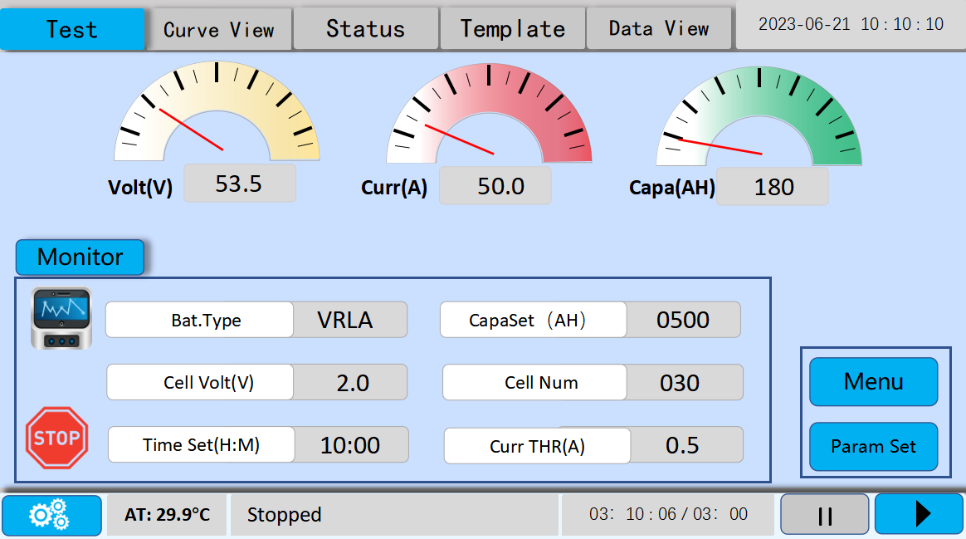
- "Volt (V)" header: It displays the real-time group terminal voltage reading of the battery group. More specifically, the voltage header shows the actual current value collected by connecting the discharge cables to the tester. And it shows the accumulative sum of single cells’ voltage.

- "Curr (A)" header: It displays the real-time current value of the battery pack charged and discharged after startup monitoring.。

- "Capa (AH)" header: It displays the real-time capacity value of the battery pack charged and discharged after startup monitoring.

- The monitoring parameter column: It displays the predefined monitoring parameters, which cannot be modified. Check whether there is any error for the parameter, if not, then proceed to the next step. If there is any error, click the "Parameter Setting" to re-set the parameters.
- “”: It indicates the online monitoring mode.

- “”: It corresponds to the threshold column showing the predefined shutdown protection parameters.

- “”: Click “Start” to start the online monitoring test, the status bar shows the monitoring status accordingly, and the time starts to count.

- “”: Click “Stop” to stop online monitoring, the status bar accordingly shows the monitoring status stops and timing stops as well.

Introduction of the Main Functions
- Curve view

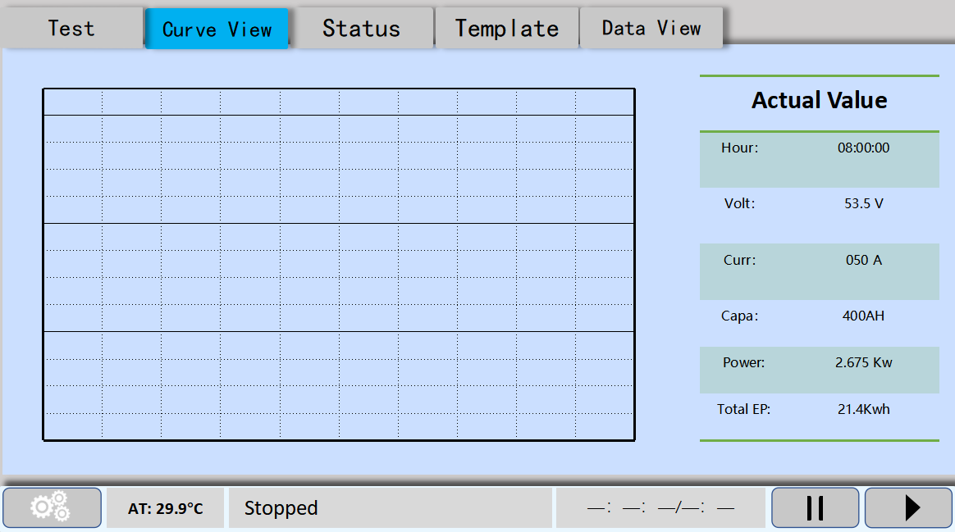
- Click "Curve View" in the menu bar to view the current and voltage curves of battery pack during charging and discharging.
- Status

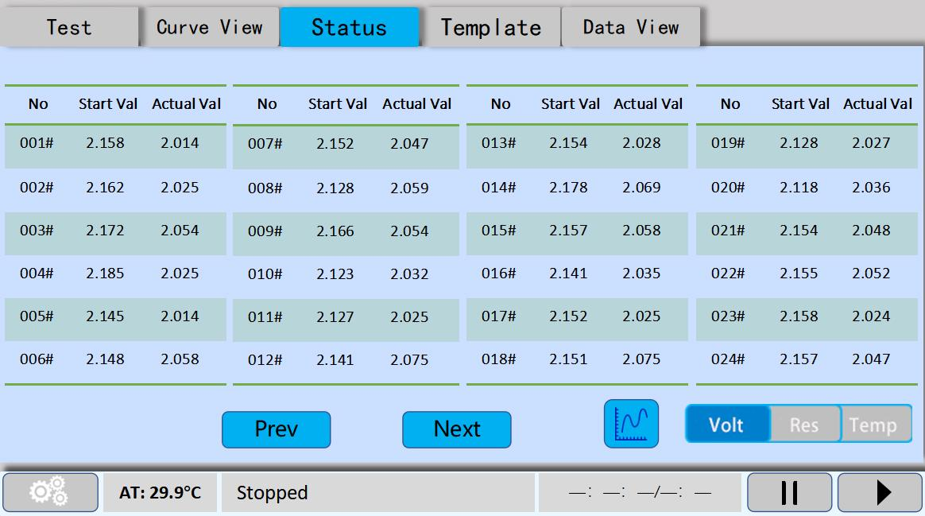
- Click "Status" to view the real-time status of each cell, the highest single-cell voltage is shown in green, and the lowest single-cell voltage is shown in red. Click "" to switch between bar graph and table, which makes it easier to find out the faulty battery.

- Template
Click "Template" to go into template interface. It supports up to 6 predefined charging/discharging parameters templates. Predefine the parameters and click “Apply” to save up the template. Whenever the template is needed, click on Invoke and the pop-up dialog box displays "Template Used.", then the parameter evoking is completed.

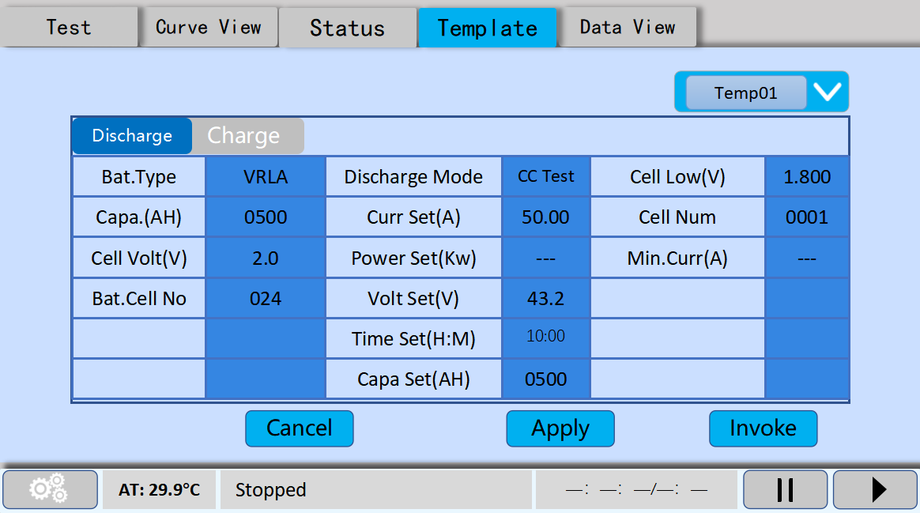
- The use of discharge template：

- Data View

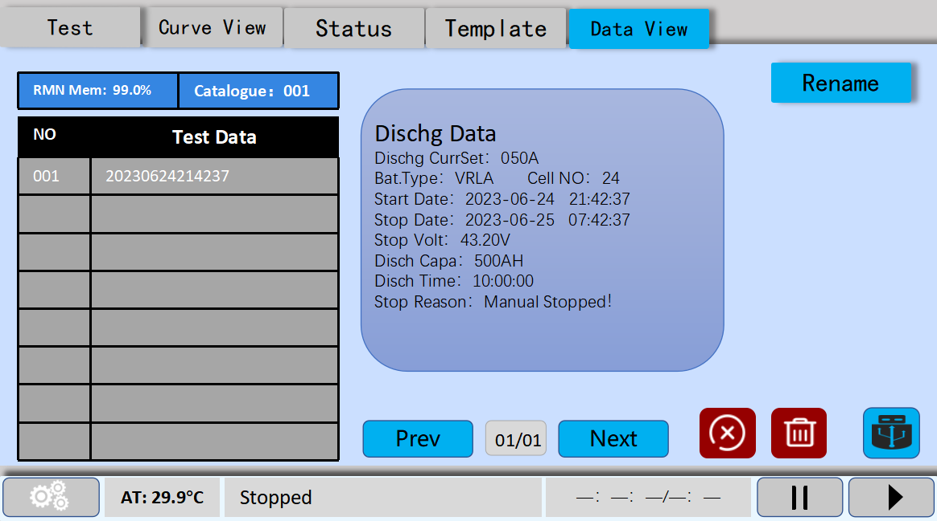

- Click “Data View” to manage the test data.

- Data Storage：
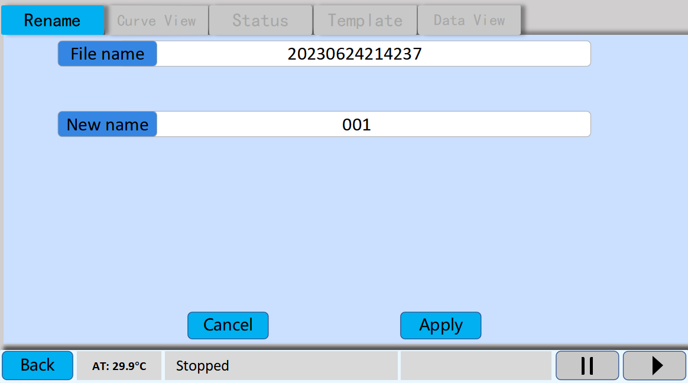
- The charging and discharging data will be automatically saved in the "Data View" interface, named after the system test.

- Data transfer：
Insert the supplied U disk, select the data on the data view interface that need to be transferred. Click “ ” and the pop-up dialog box will show the progress of the transfer. when the progress bar shows 100%, the transfer is completed successfully.
Note: Please wait for the dialog box to disappear before plugging and unplugging the USB flash drive.

- Rename：
Select the data that need to be renamed, click "Rename " to the renaming interface, enter the name that needs to be named, supporting text, symbols, and numbers input. Click "OK" to complete the renaming.

- Delete：
: Select the data to be deleted and click “Delete”, and there is a pop-up dialog box prompting whether to delete the data or not, click “Confirm” and the selected data will be deleted.
: Click it to delete all the saved data. There will be a pop-up dialog box prompting whether to delete all the data, click “Confirm” and all the data will be deleted. Please operate with caution about this function!

After-sale Service
- One-year warranty and lifetime maintenance for the products sold.
- During the warranty period, when one of the following situations occurs, the maintenance fees are charged:
- Failure or damage caused by impact during use or transportation by the user.
- The user did not keep it properly, causing the instrument to seep water, damp, hit or catch fire, etc.
- Failure or damage caused by the user or commissioned by other units to repair.
- The user malfunctions or damages the equipment due to incorrect wiring.
- Failure or damage caused by force majeure (such as fire, flood, natural disaster, etc.)
- Failure or damage caused by arbitrarily connecting other equipment not in accordance with the requirements of this manual.
- There is no product warranty card and it is impossible to confirm that the instrument is a faulty product within the warranty period.

Precautions and Maintenance
- The tester should be placed in a well-ventilated, non-corrosive, and non-strong electromagnetic field interference environment. The ventilation holes at the front and back of the main cabinet must not be blocked to ensure good ventilation.
- Do not plug or unplug the connecting terminal when the tester is working normally, otherwise the tester will be damaged.
- If the AC power is suddenly cut off during the discharging process of the tester, the fan will continue to work to dissipate heat. Do not turn off the discharge switch at this time, and make sure to turn off the discharge switch after about 1 minute.
- Please operate strictly in accordance with this manual, live operation or brutal operation is strictly prohibited.
- Avoid bumps or severe impacts during product movement.
- Pay attention to moisture and fire prevention during product storage.
- The illustrations and descriptions in this manual may be slightly different from the actual product, please refer to the actual product.
- There is a high voltage in the machine, and the maintenance software or authorized maintenance personnel of our company are not allowed to repair without authorization.
- Unauthorized disassembly and repair without the permission of the company will automatically invalidate the warranty.

Appendix 1: Operating instructions for the battery capacity tester software

Software function

1. USB data reading, display and storage；

2. Test report generation；

Installation and operation
1.Double-click the battery data analysis software installation package and follow the prompts to select the installation path to install automatically.
2.Run up the software, as shown in Figure 2.1:
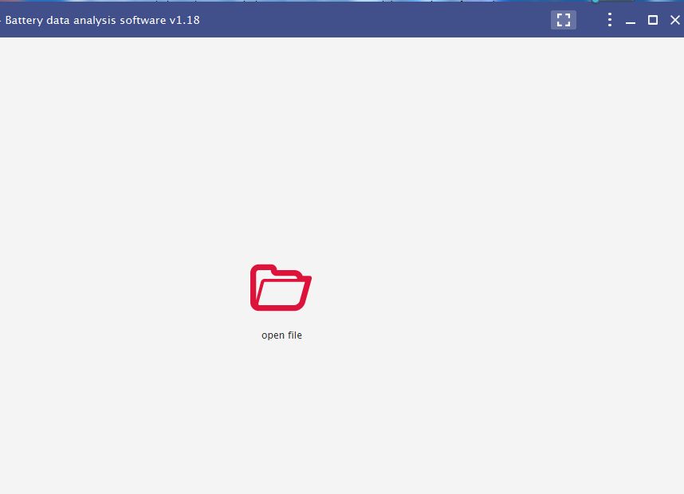
Fig.2.1

U disk data read, display and storage
During the discharge, the discharge data can be saved in the memory of the instrument. After the discharge is over, the discharge data can be transferred to the computer for analysis via the U disk.
- Determine where the data is stored in the computer;
- Double-click "Select Test File" to pop up a dialog box; as shown in Figure 3.1;
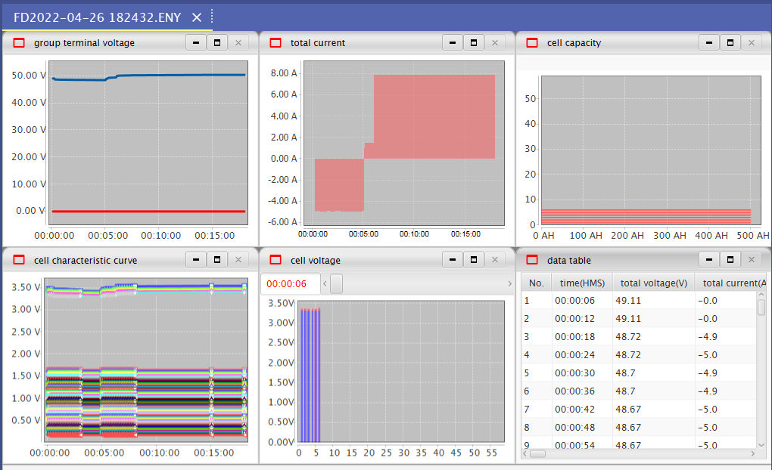
Fig 3.1
- Select the data to be analyzed and open it, and various discharge parameter curves will be displayed on the interface, as shown in Figure 3.2
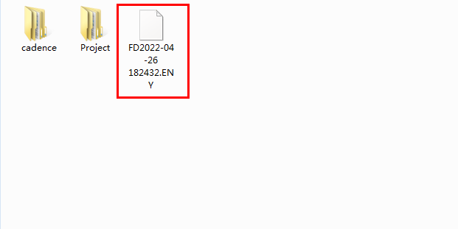
Fig 3.2

Report Export
- Click the title bar icon, as shown in Figure 4.1.
Fig.4.1
2. Click the drop-down menu to choose between exporting word and excel reports.
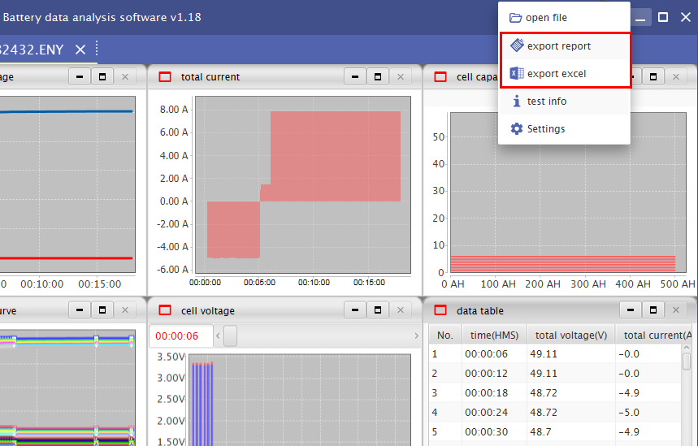
Fig 4.2
3. A dialog box will pop up, name the file name and select the file storage path, the software will automatically generate a word or excel format file.

Fig 4.3
Note: Please make sure that Office software is installed in your computer.

Appendix 2: Lead-acid battery discharge coefficient corresponding table
Discharge Rate | Percentage of rated capacity | Current percentage of rated capacity | Termination voltage
10h discharge rate | 100% | 10% | 1.8V
9h discharge rate | 97.4% | 10.8% | 1.8V
8h discharge rate | 94.4% | 11.4% | 1.8V
7h discharge rate | 93% | 12.4% | 1.8V
6h discharge rate | 91.7% | 13.3% | 1.8V
5h discharge rate | 87.6% | 14.6% | 1.8V
4h discharge rate | 80% | 20% | 1.8V
3h discharge rate | 75% | 25% | 1.8V
2h discharge rate | 61.1% | 30.55%
1h discharge rate | 55% | 51.4% | 1.75V
0.5h discharge rate | 45% | 70% | 1.7V

Appendix 3: Common Instruments and Wiring Troubleshooting
No. | Problem | Solutions
1 | The voltage of a single module is all 0. | Check and confirm the wiring method of the wireless module.
2 | The voltage of the first three cells of each wireless module is 0. | The wiring sequence is reversed. It should be from No. 0 to No. 6,and start from the positive pole.
3 | Module indicator light is off. | The red and black clips of the module require a minimum power of more than 8V.
4 | The indicator light of the module flashes slowly, and the module cannot receive data. | The number of modules for the tester is incorrectly filled, and the module location exceeds the range.
5 | Buzzer sounds when discharge cable is connected. | The positive and negative connection of the discharge cable is reversed.
6 | The discharge current is normal and the voltage does not drop. | The battery pack is not disconnected from the system.
7 | Uncontrolled current during discharge. | Please confirm that the internal and external current sensors are selected correctly.
8 | Discharge current fault | The air circuit breaker is not closed, the final discharge circuit is not connected, or the battery capacity is too small, and the discharge current is insufficient.
9 | Over temperature fault | Confirm the placement of the discharger, pay attention to ventilation and heat flow.
10 | After the power is turned on, there is current when the air switch is closed | The discharge circuit may be burnt out and need to be returned to the factory.
11 | Data cannot be saved. | Restart the machine, do not switch between internal storage and external storage during the discharge process.

Declaration

The company will improve and perfect the technical performance of the tester in due course. At the same time, this manual may be partially changed as the product is upgraded and improved. The user’s manual is subject to change without notice.

